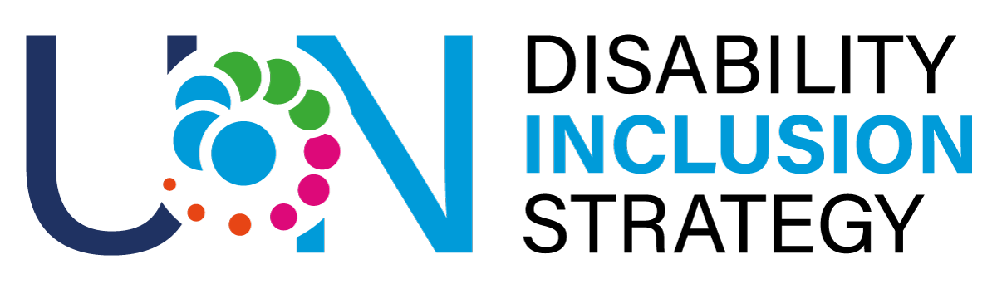

Inclusive procurement checklist of the United Nations in Guatemala

Inclusive suppliers

The purpose of the list is to identify if suppliers which we source from offer goods and services with an accessible and inclusive approach. Motivating companies to apply accessibility measures in their policies contributes to improving attention to the issue and promoting inclusive actions. Likewise, it is important to have a mapping of suppliers with accessibility policies in the country, with particular emphasis on those owned by women and people with disabilities.

The following table contains several sample questions which can be included in the solicitation documents for the procurement of goods, works or services and which can help identify disability-inclusive suppliers. Depending on the nature of the requirement, some questions may be more relevant or less relevant. In response to the questions, suppliers will need to provide appropriate evidence to show that they are indeed disability inclusive.

Suppliers are considered inclusive if they can show positive evidence for at least two of the questions in the following table.

Table 5. Checklist for assessing inclusive bidders / suppliers
Suppliers / Bidders
1 | Does the supplier have a general inclusion policy for persons with disabilities? If yes, please provide details. | Open answer
2 | Does the supplier employ persons with disabilities? If yes, please provide details. | Open answer
3 | Does the supplier have a policy that foresees the provision of reasonable adjustments to persons with disabilities (e.g. applicants, employees, suppliers, visitors) who so require? If yes, please provide details such as, for instance, a registry of requests for adjustments made and their status. | Open answer
4 | Does the supplier require its own suppliers to be disability-inclusive? If yes, please provide details such as a respective policy or written agreements. | Open answer
5 | Does the supplier engage or consult persons with disabilities in the development of its products or services? If yes, how? | Open answer
6 | Is the company owned by: (i) women, (ii) people with disabilities, (iii) youth, (iv) intersectional? If yes, please provide details. | Open answer

Inclusive venues

The purpose of the list is to identify if the venues we use are accessible to persons with disabilities. Many venues will claim to be accessible but may only be partially accessible. A site visit will help the meeting organizers to better understand the provided accessibility features. Any site visit should include talking with venue staff to answer questions regarding modifications that can be made. The following accessibility features should be considered during the site visit when selecting a venue and checked again just before the meeting to ensure that they are still in place.

Table 6. Checklist for assessing inclusive venues
Question |  | Yes | No / NA
Outside of the venue
1 | Is the facility centrally located and close to public transportation?
2 | Is the site clearly identified with directions on how to get there?
3 | Do the streets, avenues and/or alleys leading to the site allow for the passage of wheelchairs, baby carriages, canes or other technical mobility aids?
4 | Is the parking area ample and does it have ramps? Are there accessible parking spaces near the entrance?
5 | Does the facility allow guide dogs to enter (and stay, if accommodation is included)?
6 | Are the access doors to the facility at least 81.3 cm wide?
7 | Are the spaces dedicated to people with disabilities clearly marked with the international symbol of accessibility?
8 | Are access corridors marked with "No Trespassing" signs?
9 | Is there sufficient lighting for people with low vision?
10 | Is there a physical, step-free access to the entrance?
Security
11 | Are emergency exits clearly identified and accessible?
12 | Do fire and emergency alarms have audible and visual signaling?
13 | Is there an evacuation plan for people with disabilities?
14 | Is there a designated relief area for service animals?
15 | Is staff trained on how to assist people with various types of disabilities in case of an emergency?
Inside the venue
16 | Is there a physical, step-free access to the emergency exits, stage/speakers’ platform, toilets, corridors, dining areas, and other public areas?
17 | If the event is on an upper floor, is there an elevator?
18 | Are the signs of the meeting rooms in large print, Braille or with easily interpreted symbols?
19 | Are there lines on the floor or wall for people with low vision or visual impairments?
20 | Are access doors at least 1 meter wide?
21 | Are all accessible routes clear of objects that could hinder passage?
22 | Is the passage to circulate inside the room at least 1 meter wide?
23 | If there is a stage or raised area, does it have a ramp and handrail?
24 | Can the chairs inside the venue be moved to make room for a wheelchair?
25 | Is there an installed audio support system (microphones)?
26 | Are there at least two or more roving microphones available for participants with disabilities and sign language interpreters for spoken interpretation.
27 | Are assistive listening devices available for individuals with hearing impairments?
28 | Are there large screens with good color contrast for projection?
29 | For events, are there provisions for remote participation options (e.g., streaming with captions and sign language interpretation) to increase accessibility?
30 | Are there dedicated areas for sign language interpreters available who would assist attendees who are deaf or hard of hearing?
31 | Are there quiet rooms or sensory-friendly areas available for individuals with autism or sensory processing disorders?
32 | Are efforts made to minimize sensory overload in event spaces, such as controlling noise levels and providing areas for rest and recovery?
33 | Are first aid stations accessible?
34 | Are venue staff trained to assist people with various types of disabilities in case of an emergency? Is there ongoing training for venue staff on disability awareness and how to assist guests with disabilities?
Restrooms / Bathrooms
35 | Is the route to the restrooms accessible?
36 | Is there signage in non-accessible restrooms indicating where accessible restrooms are located?
37 | Is the restroom door at least 81.3 cm wide and outward opening?
38 | Does the restroom door open with a lever or other easily accessible mechanism (taking into account height and ease of activation)?
39 | Are there accessible toilets that meet the following specifications?  - 1.5 x 1.5 meters of clear space  - height from the floor of between 0.43 and 0.48 cm  - grab bars on the side and back of the toilet between 83.8 and 91.4 cm from the floor
40 | Are there accessible sinks that meet the following specifications?  - knee clearance 73.6 cm deep  - height to allow for use by persons of small stature  - grab bars
41 | In the case of the bathroom inside the room, does it have a free space of 1.5 x 1.5 meters to allow a wheelchair user to maneuver, at least?
42 | In the case of the bathroom inside the room, are there support bars in the shower?
Rooms for accommodation (if appliable)
43 | Are the rooms on the first floor or, if not, are there elevators to access rooms on higher floors?
44 | Are there handrails, guidelines or easily interpreted symbols to indicate how to access to rooms?
45 | Is the access door to the rooms at least 1 m wide?
46 | Does the room have only the necessary furnishings (bedside tables, closet, bed, bench, etc.) so as not to hinder mobility within the room?
47 | Is there space around the beds for wheelchairs, walkers, crutches or similar?
48 | Are there grab bars or other tools to reach the bed?
49 | Are the closets 1.20 meter high or are they adjustable?
50 | Are communication services easily located and preferably with tactile signage?
51 | If there is a desk, does it have enough space to allow wheelchair users to use it?
52 | If there is a desk, does it have a chair or armchair with armrests?

Assessing the accessibility of venues

Our current target is to have at least 10 features indicated in the above table with “Yes”. Count the number and insert it below. Remember that this is only an indication – the actual accessibility will depend on the specific requirements of your participant and even one missing feature may prevent a person with a disability from participating fully in the meeting or event. Therefore, it is critical that you engage with your participants to understand their specific needs.

If certain features are not met, a written communication by the venue can be accepted in which they commit to implement them within a period of 6 months to 1 year with a scheduled verification date to be carried out by the UN Advisory Council.

Rating. How many accessibility features does the venue meet?  (Total number of positive responses) | ____ (open answer)
Commitment to improvement. Will the conditions not complied with be implemented within a maximum period of 1 year and has the venue provided a written confirmation on that? | ____ (open answer)

Review | Status | Notes
Consultation with participants | Not started
Verification with supplier | In progress
On-site verification by OMT-PMT-Advisory Council | Under review
Inclusion of requirements in service contracting | Approved

DATE______________________________
ADMINISTRATIVE MANAGER____________________________________________________________
PROGRAMMATIC MANAGER_____________________________________________________________
OPERATIONS MANAGER______________________________________________________________

UN Guatemala is grateful to Mr. Alexander Blecken, Managing Director of SPOT Advisory GmbH, for his review and enhancements of this checklist.
Step-free access includes access via lifts, ramps of a reasonable gradient with handrails, or level access, avoiding gaps or slippery surfaces or other barriers.

